CURRICULUM VITAE
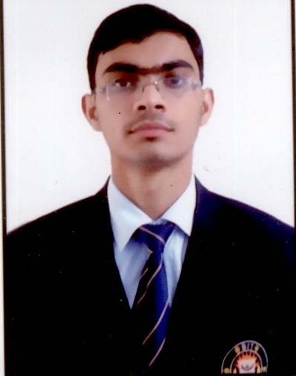

Ankur Sharma
B.Tech (Mechanical Engg.)
Bharat Institute of Technology,
Meerut (U.P.) India

Cell Phone Number
8937822103

E-mail
ankursharma371@gmail.com

Father’s Name
Mr. Ajay Sharma

Mother’s Name
Mrs. Manju Sharma

Permanent Address
Vill- Kanchanpur Ghopla, Shatabdi Nagar,
Meerut – 250103
(UP) India.

Personal Data
Date of Birth : 10thAug,1996
Nationality : Indian

Area of interest
Production Engineering
I.C Engine

Hobbies
Listening to music
Reading newspaper

Languages known
English
Hindi

Career ObjectiveTo obtain a position of responsibilities in an organization where I could get the chances of growth & could utilize my technical and personal skills for moving up the graph of the organization.

Branch of StudyMechanical Engineering

Academic Qualification
QualificationYear of PassingInstituteBoard/UniversityPercentageB.Tech.
(Mechanical Engineering)PursuingBharat Institute of Technology, MeerutUttar Pradesh Technical University, Lucknow68.78
(till 7th Sem.)Senior Secondary2012MSS Inter College, MeerutUP Board73.80Higher Secondary2010MSS Inter College,
MeerutUP Board67.50

Final Year ProjectProject : Savonius Turbine Based Electricity Generator.
Duration : During Final Year
Summary : The terms wind energy or wind power describe the process
by which the wind is used to generate mechanical power or
electricity. Savonius turbine converts the kinetic energy in
the wind into mechanical power. This mechanical power
can be used for specific tasks (such as grinding grain or
pumping water ) or a generator can convert this mechanical
power into electricity.

Summer Internship ProjectCompany : 510 Army Base Workshop
Title : Illustrated Part List Of Main Gear Box and Hull Repair
Duration: 15th June to 11th July 2015
Summary: Acquired the knowledge about repairing and overhauling of
Indian Army weapons (such as- Schilka tank) and gained the
knowledge about the functioning of main gear box
and hull repair of schilka tank.

Training Title: CREO
Duration: Two weeks (4th July 2014 to19th July 2014)
Institute : Advance Engineering Training, Ghaziabad, U.P

Image

Achievements
- Got distinction in Mathematics II during B.Tech -Ist year.
- Secured 89% & 79% marks in Physics and Mathematics respectively in class XIIth.
- Stood first in XIIth and XIth UP Board Examinations at MSS Inter College, Meerut.
- Secured above 67% throughout my academic career.

Key Skills Proficiency
- Well versed with latest computer softwares like Creo, MS Office & Window 7
- Self-motivated & Punctual.
- Good communication skills
- Can work effectively in team, as well as individually.
- Have good inter-personal as well as presentation skills

Extra Curricular Activities
- Participated in “Go Kart Design Challenge Championship 2015” in March, 2015 & secured 27th rank out of 192 teams who had taken part from various cities of India.
- Participated in Singing competition in class XIIth
- Secured First position in Long Jump in class Xth

Position of Responsibilities
- Worked sincerely in Braking department of team “Lakshya” in “Go Kart Design Challenge Championship 2015”.
- Elected as “Discipline In-charge” in class XIIth

Declaration
I hereby declare that the above information is correct to the best of my knowledge and belief.

Date : ..............................
Place : .............................. (Ankur Sharma)

